Skyline QuaSAR Quantitative Statistics

QuaSAR is a program that aids in the Quantitative Statistical Analysis of Reaction Monitoring Experiments. It was designed to quickly and easily convert processed SRM/MRM-MS data into calibration curves, determine limits of detection and quantification, calculate mean and coefficient of variation for all transitions of each peptide in a set of samples, as well as determine the peptide analyte concentration in unknown samples. The resulting output files, consisting of *.csv tables and *.pdf figures, can be readily used for further statistical analyses or reported as output for reports or publications.

In order to use QuaSAR, two files must be provided: a **Skyline Report File** containing peak areas that Skyline measured and a **Concentration Map File** listing the analyte concentrations of the samples**.** This tutorial covers how to export the Skyline Report file and how to create the Concentration Map File in Microsoft Excel.

# Getting Started

To start this tutorial, download the following ZIP file:

<https://skyline.gs.washington.edu/tutorials/QuaSAR.zip>

Extract the files in it to a folder on your computer, like:

C:\Users\brendanx\Documents

This will create a new folder:

C:\Users\brendanx\Documents\QuaSAR

The zip file contains the following files:

QuaSAR_Tutorial.sky: A Skyline document containing sample data for QuaSAR.  
QuaSAR_Tutorial.skyd: Contains extracted chromatogram data for the Skyline document.

Open the provided file QuaSAR_Tutorial.sky in Skyline.

# Annotating samples with concentration information

Skyline allows you to associate additional information with the replicates in the document by defining custom annotations.

To create an annotation, perform the following steps:

* On the **Settings** menu, click **Annotations**.
* Press the **Edit List** button to bring up the **Define Annotations** form.

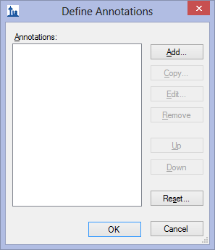

The first annotation that will be required by QuaSAR is called “SampleID”, which will indicate what material was used for a particular replicate. To create this annotation, do the following:

* Click the **Add** button in the **Define Annotations** form.
* Enter ‘SampleID’ in the **Name** field of the **Define Annotation** form.
* Leave ‘Text’ as the value in the **Type** dropdown list.
* Check the **Replicates** checkbox in the **Applies To** list.

The **Define Annotation** form should look like:

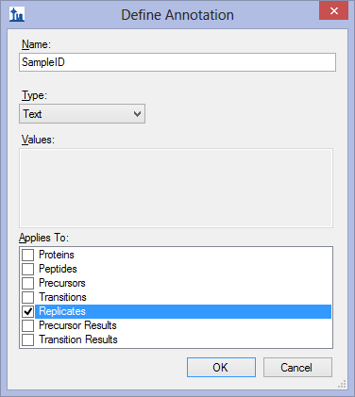

* Click the **OK** button.

The second annotation that will be required by QuaSAR is called “Analyte Concentration”. To create this annotation, do the following:

* Click the **Add** button in the **Define Annotations** form.
* Enter ‘Analyte Concentration’ in the **Name** field of the **Define Annotation** form.
* Choose ‘Number’ in the **Type** dropdown list.
* Check the **Replicates** checkbox in the **Applies To** list.

The **Define Annotation** form should look like:

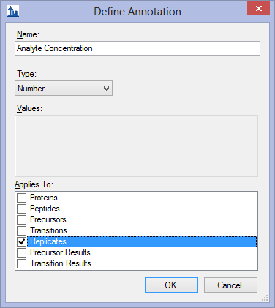

* Click the **OK** button.

The second annotation that will be required by QuaSAR is called “IS Conc” for internal standard concentration. To create this annotation, do the following:

* Click the **Add** button in the **Define Annotations** form.
* Enter ‘IS Conc’ in the **Name** field of the **Define Annotation** form.
* Choose ‘Number’ in the **Type** dropdown list.
* Check the **Replicates** checkbox in the **Applies To** list.

The **Define Annotation** form should look like:

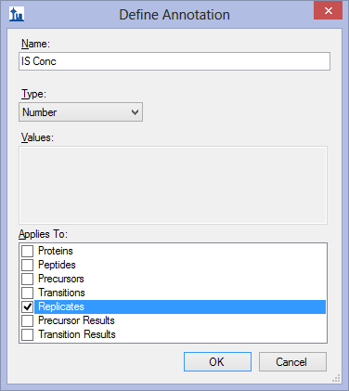

* Click the **OK** button.
* Click the **OK** button in the **Define Annotations** form.

The **Annotation Settings** form will show the list of the annotations that you have just defined, but you must check the checkboxes in the list in order to be able to use these annotations in your current Skyline document. The **Annotation Settings** form should look like the one shown below:

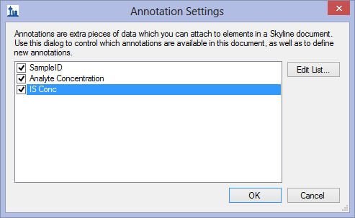

* Click the **OK** button.

Editing annotation values in Skyline is done using the Results Grid. To bring up the Results Grid do the following:

* On the **View** menu, click **Results Grid** (Alt-2).

The **Results Grid** will show you chromatogram peak areas and other measured results for the currently selected peptide, or transition. This amount of data might be distracting while typing in the annotation values, so be sure that one of the proteins is selected in the **Targets** tree view.

The **SampleID** column should be filled in with the single letter found in the replicate name. Use this table to fill in the **Analyte Concentration** values:

|  |  |  |  |  |  |  |  |  |  |  |
| --- | --- | --- | --- | --- | --- | --- | --- | --- | --- | --- |
| SampleID | A | B | C | D | E | F | G | H | I | J |
| Analyte Concentration | 0 | .001 | .004 | .018 | .075 | .316 | 1.33 | 5.62 | 23.71 | 100 |

All of the samples in this experiment have an **IS Conc** value of 10**.**

If you see the main Skyline window flashing as you type in the **Results Grid**, you may want to allow Skyline to change rows in the grid without activating the corresponding replicate chromatogram graph, by doing the following:

* Right-click in the **Results Grid**, and click **Synchronize Selection**.

The completed grid should look like this:

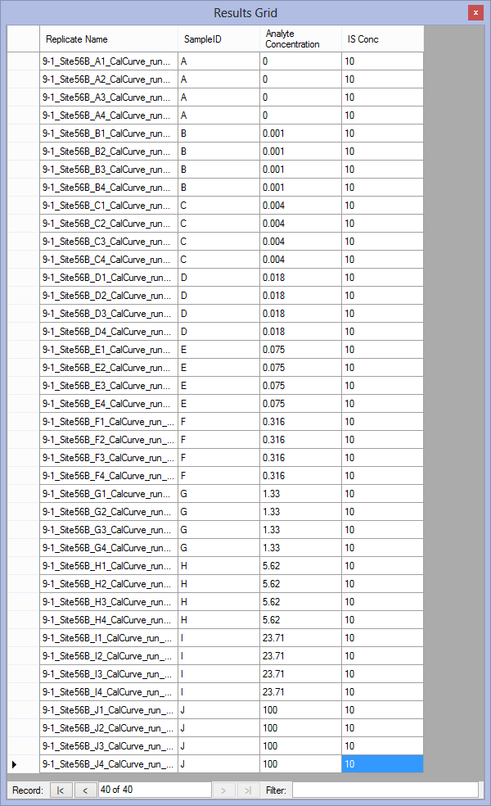

# Creating the concentration map file

To create the concentration map file required by QuaSAR, perform the following steps:

* Using a spreadsheet program such as Microsoft Excel, create a new spreadsheet with the following values in the first row:

|  |  |  |  |  |
| --- | --- | --- | --- | --- |
| SampleName | SampleID | Analyte Concentration | IS Conc | Concentration Ratio |

* In the **Results Grid** in Skyline, click and drag to select all of the rows and columns of data.
* Press **Ctrl-C** to copy the data to the clipboard.
* In Excel, paste the clipboard data into the second row.
* Save this file to Concentration.csv in the folder you created for this tutorial with **Save as type** set to ‘CSV (Comma delimited) (*.csv)

The spreadsheet should look something like this:

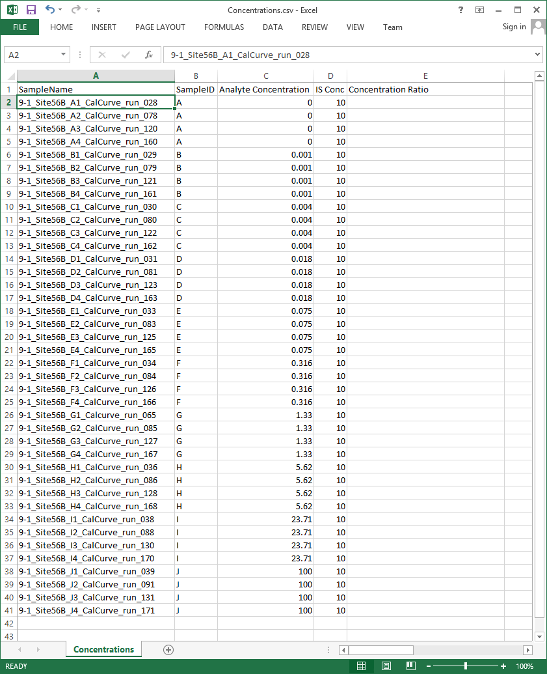

* Close the **Results Grid** in Skyline by clicking the red X in its upper right corner.

NOTE: In a future version, QuaSAR will accept a single report from Skyline which incorporates the concentration map information you just entered with the peak are information you are about to export. The current version of QuaSAR was designed before support for replicate annotations was added to Skyline in version 1.4.

# Exporting QuaSAR input data

To create the Skyline report required by QuaSAR, you will use the built in custom report template installed by default with Skyline. To export this report for the tutorial document, do the following:

* On the **File** menu choose **Export** and then click **Report**
* Select **QuaSAR Input** in the report list.

The **Export Report** form should look like:

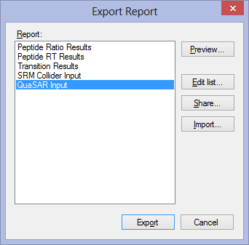

* Click the **Export** button.

Skyline will give the option to name the file which defaults to “QuaSAR_Tutorial.csv”.

* To accept this report name, click **Save**.

If properly exported, the final .csv Skyline Report file will already be correctly formatted and contain columns with the following headers (with **exact** spelling, capitalization and spaces)

**FileName**

**SampleName**

**ProteinName**

**ReplicateName**

**PeptideSequence**

**PrecursorCharge**

**ProductCharge**

**FragmentIon**

**AverageMeasuredRetentionTime**

**light Area**

**heavy Area**

This is what the exported file will look like if you open it in Excel:

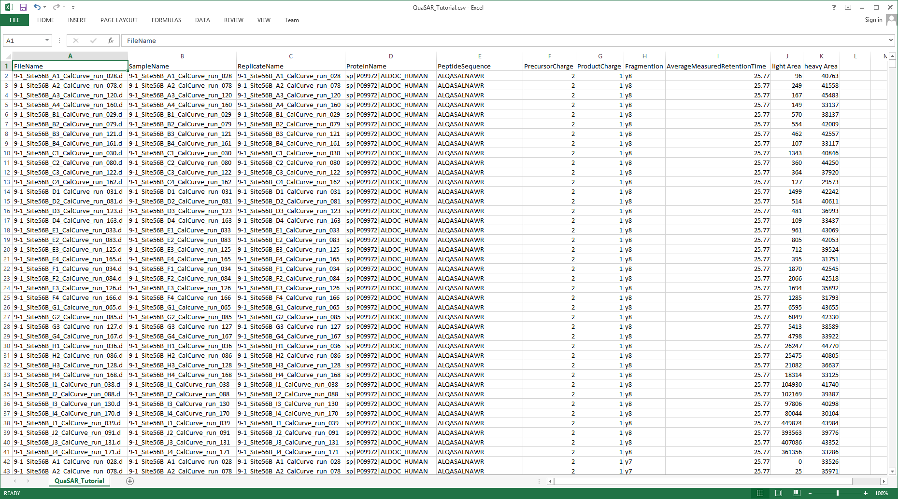

# Using QuaSAR

To bring up the QuaSAR web site from Skyline, do the following:

* On the **Tools** menu, click **QuaSAR**.

You also can navigate a web browser to the GenePattern web page:

<http://genepattern.broadinstitute.org/gp/pages/index.jsf?lsid=QuaSAR>

Unless you have already signed in to the GenePattern web site, this will bring you to the GenePattern sign-in page, and you will need to sign in to GenePattern. If you do not have a GenePattern ID then click the “[Click to Register](http://genepattern.broadinstitute.org/gp/pages/registerUser.jsf)” link to register for an account before you can sign in.

You will now be on the QuaSAR module page. To specify the **Skyline Report File** and **Concentration Map File** you just created for QuaSAR to use, do the following:

* In the **skyline file** field, click the **Choose File** button to invoke the file navigator.
* Locate and select the QuaSAR_Tutorial.csv file that you exported from Skyline.
* Click **OK** to accept your choice of file.
* In the **concentration file** field, click the **Choose File** button to invoke the file navigator.
* Locate and select the Concentrations.csv file that you saved from Excel.
* Click **OK** to accept your choice of file.
* In the **title** field, enter ‘Tutorial’.

For this tutorial you will leave the rest of the options in their default settings. If you wish to learn more about the many options provided by QuaSAR, click the [**documentation**](http://genepattern.broadinstitute.org/gp/module/doc/urn:lsid:broad.mit.edu:cancer.software.genepattern.module.analysis:00298:1) link in the top right of the module page.

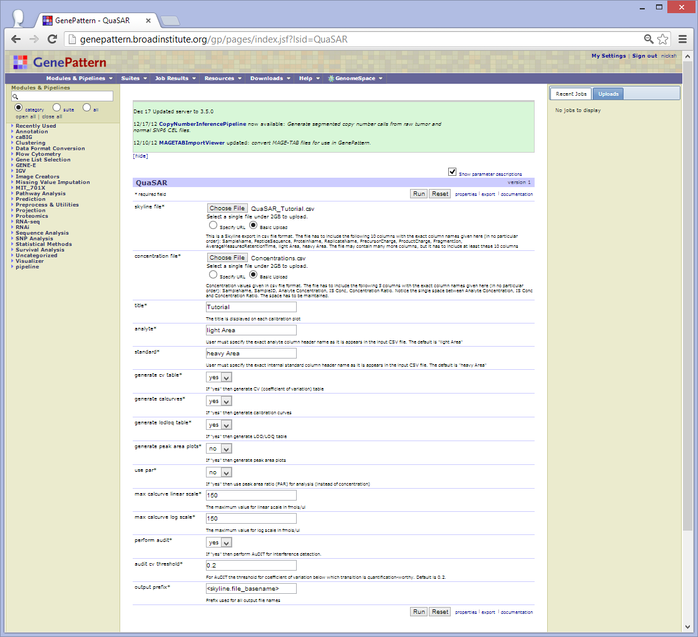

**Fig. 4.** The QuaSAR Module. Setup is finished and QuaSAR is ready to run.

* Click the **Run** button.

This will take you to a new page where it should indicate that your QuaSAR request has been submitted. If you wish to be notified by email when QuaSAR is finished select the email notification box in the right corner of the QuaSAR bar. It will take approximately 5 minutes for QuaSAR to finish.

Once QuaSAR has finished, you will see a list of files on the same page **(Fig. 5).** These files represent the output from QuaSAR. You can view these files by clicking on them.

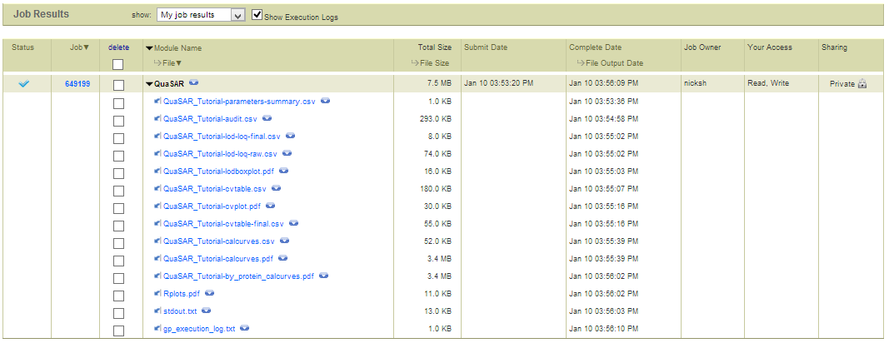

Download menu  
button

The QuaSAR output screen after finishing the tutorial. The button for the dropbox menu that contains the **download** option is indicated.

To download the output files from the QuaSAR module, click the small blue arrow next to "QuaSAR" on the module title. This will reveal a drop box. In the drop box there will be an option to download. Click on **download** and all the QuaSAR output files will be automatically zipped up into one single file and downloaded onto your computer.